MINI HOVERCRAFT

Project under “Team Mavericks”

SLIET

**MINI HOVERCRAFT**

A **hovercraft**, also known as an **air-cushion vehicle** or **ACV**, is an amphibious craft capable of travelling over land, water, mud, ice, and other surfaces.

Hovercraft use blowers to produce a large volume of air below the hull, or air cushion, that is slightly above atmospheric pressure. The pressure difference between the higher pressure air below the hull and lower pressure ambient air above it produces lift, which causes the hull to float above the running surface. For stability reasons, the air is typically blown through slots or holes around the outside of a disk- or oval-shaped platform, giving most hovercraft a characteristic rounded-rectangle shape.

**Working principle of Hovercraft**

Hovercraft use blowers to produce a large volume of air below the hull that is slightly above atmospheric pressure. The pressure difference between the higher pressure air below the hull and lower pressure ambient air above it produces lift, which causes the hull to float above the running surface. For stability reasons, the air is typically blown through slots or holes around the outside of a disk or oval shaped platform, giving most hovercraft a characteristic rounded-rectangle shape. Typically this cushion is contained within a flexible “skirt”, which allows the vehicle to travel over small obstructions without damage.

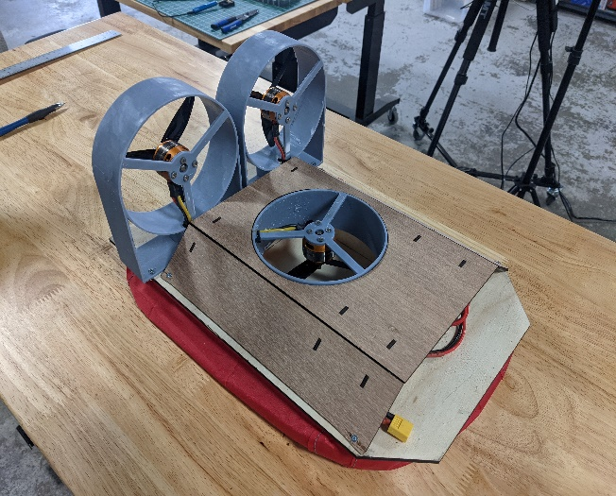

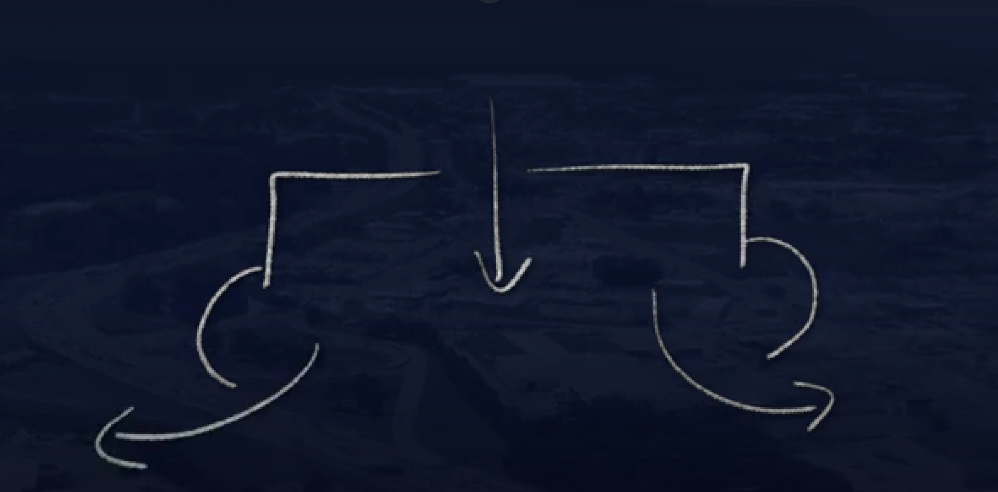

**Components (For 2 hovercrafts)**

|  |  |  |  |  |
| --- | --- | --- | --- | --- |
| **S.no.** | **Components** | **Quantity** | **Links** | **Price** |
| **1** | Brushless DC Motor  (3300 kv) | 6 |  |  |
| **2** | Electronic speed controller (esc)  (40 Amp) | 4*bidirectional  2*unidirectional |  |  |
| **3** | Transmitter with receiver | 1 |  |  |
| **4** | Li-po battery | (2*3300 mAH)  (2* 2200 mAH) |  |  |
| **5** | Propellors  (5*5*3) | 8 |  |  |
| **6** | **(5mm diameter) standard wire** | 2 m |  |  |
| **7** | **(3mm) sanded plywood/solid PVC sheet** | 1 sq.m |  |  |
| **8** | **Nylon fabric for skirt** | 1 sq m |  |  |

**BLDC KV V/S Propellers**

|  |  |  |  |  |
| --- | --- | --- | --- | --- |
| KV | PROPELLER | VOLT | AMPERE | THRUST |
| 980 | 10 INCH | 12 | 12 | 880G |
| 1000 | 10 INCH | 12 | 13 | 950G |
| 1200 | 9/10 INCH | 12 | 16/14 | 1100/1000 |
| 1400 | 8 INCH | 12 | 18 | 850G |
| 1800 | 7 INCH | 12 | 15 | 800G |
| 2200 | 6 INCH | 12 | 24 | 900G |
| 2700 | 6 INCH | 12 | 28-30(ESC-40) | 1150G |
| 3000 | 5INCH | 12 |  |  |
| 3300 | 5 INCH |  |  |  |
|  |  |  |  |  |

**Procedure for Hovercraft:**

1. **Selecting the Hovering method:**

We have two method : We are going to choose cutting method.

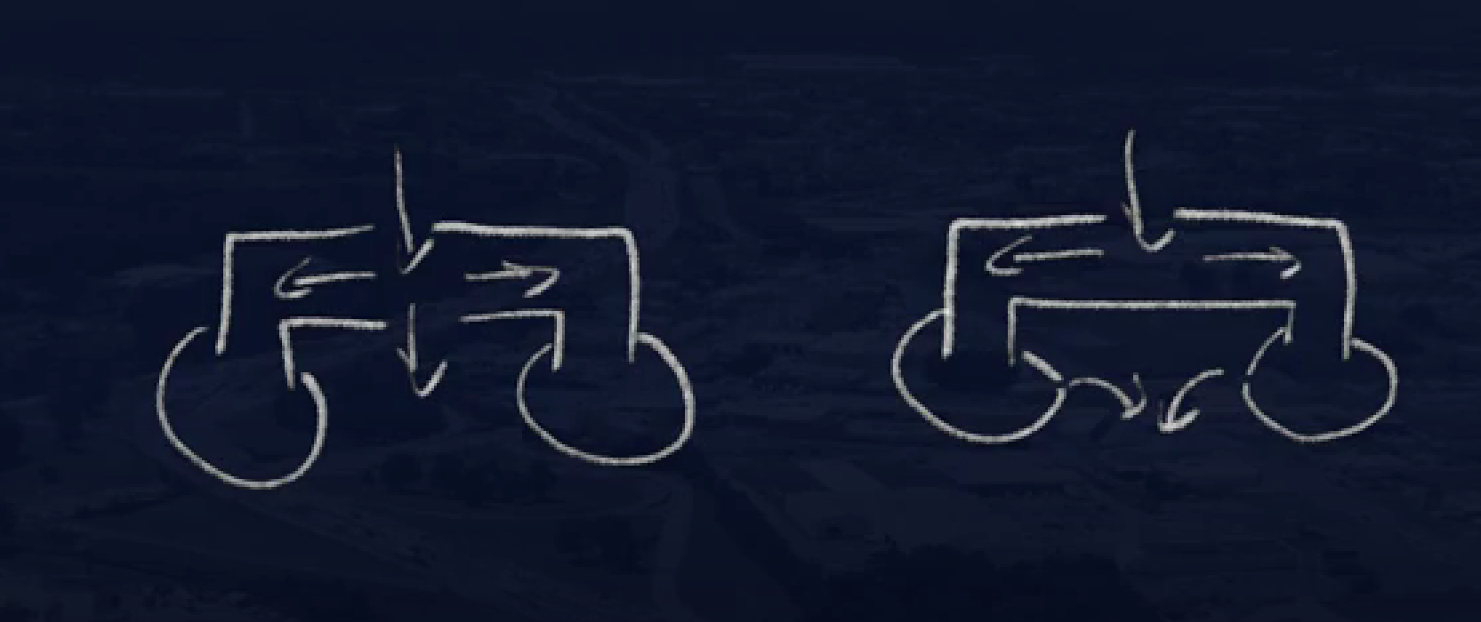

**Cutting Holes**

1. **Choosing between radar or two propulsion system:** We are going with two propulsion system

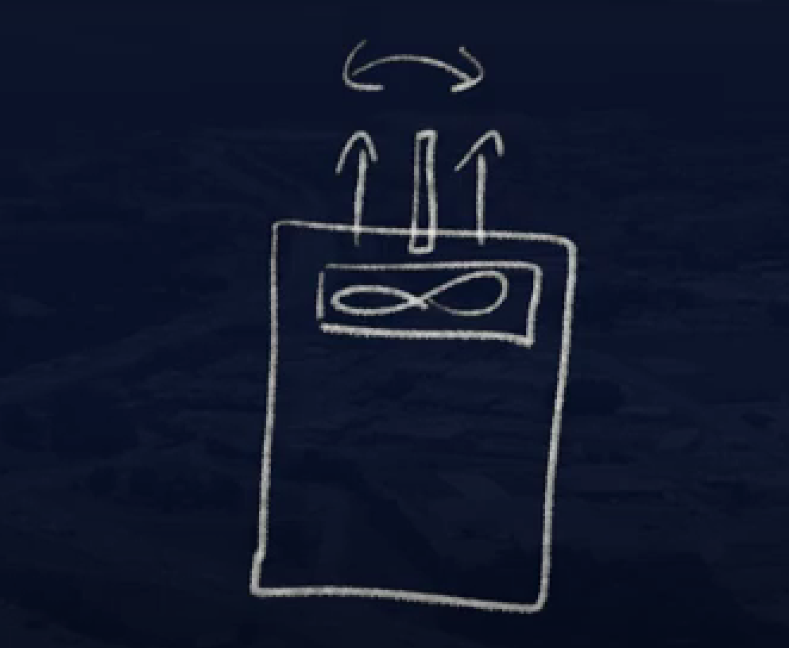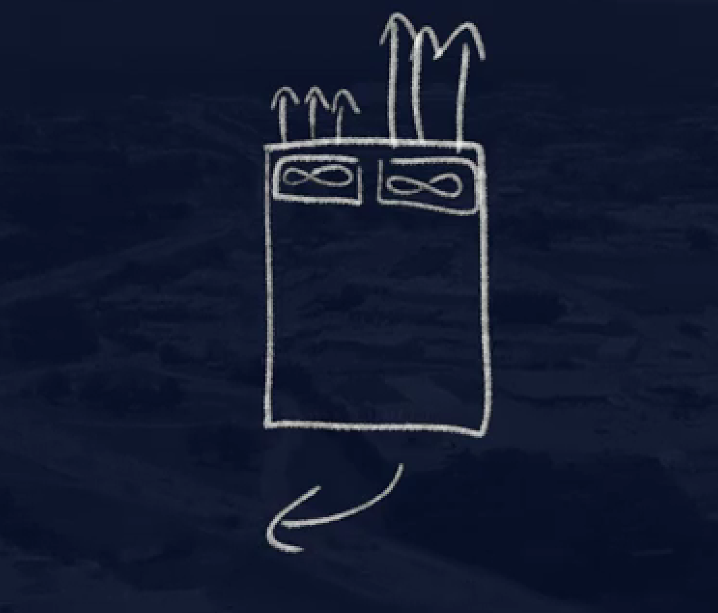

1. 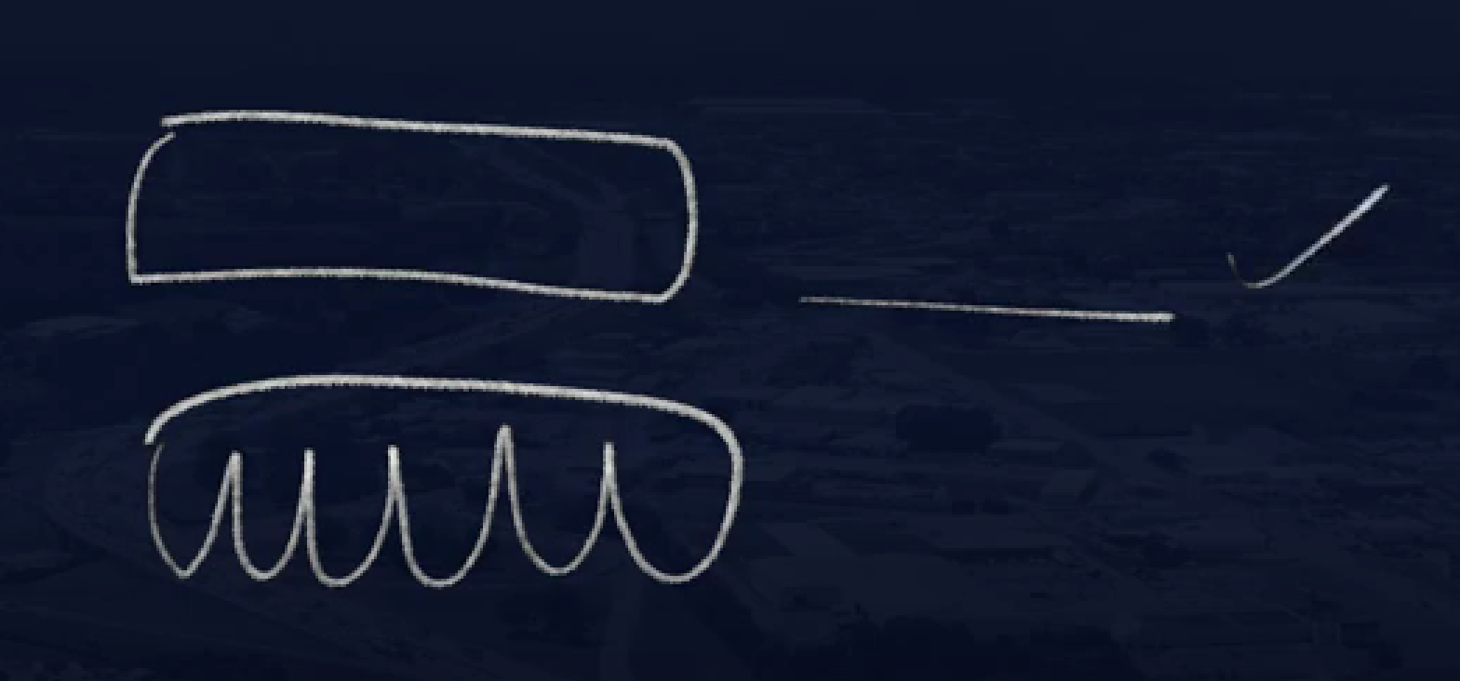**Choosing skirt method:** We are going with simple skirt method.
2. **Design of Base:**

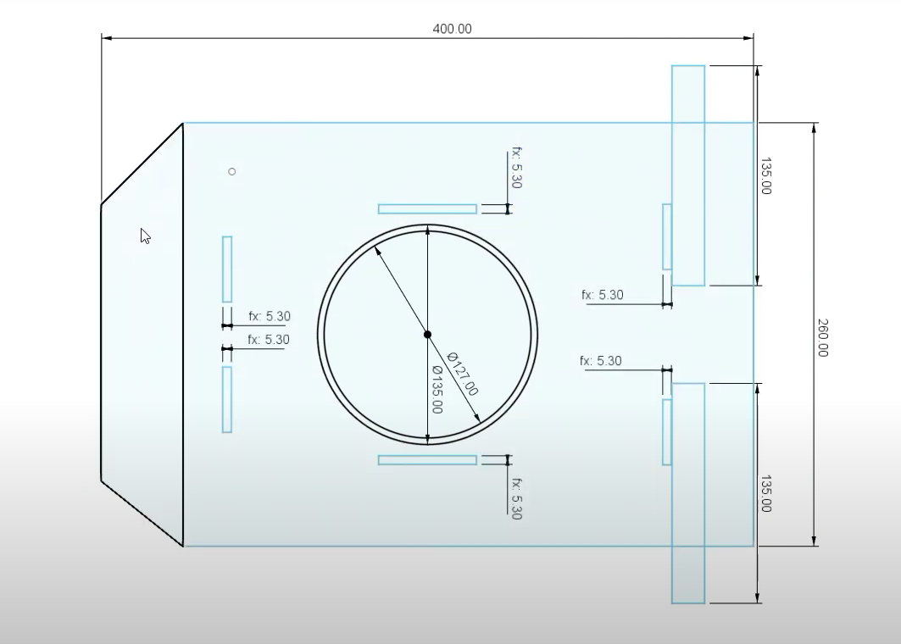

1. **Design for exhaust for center and back:-**

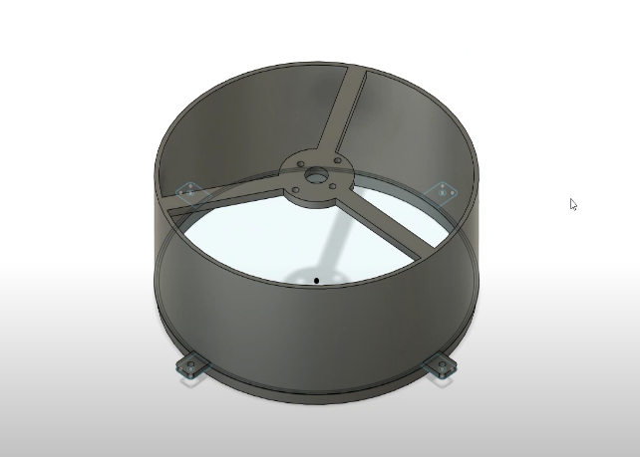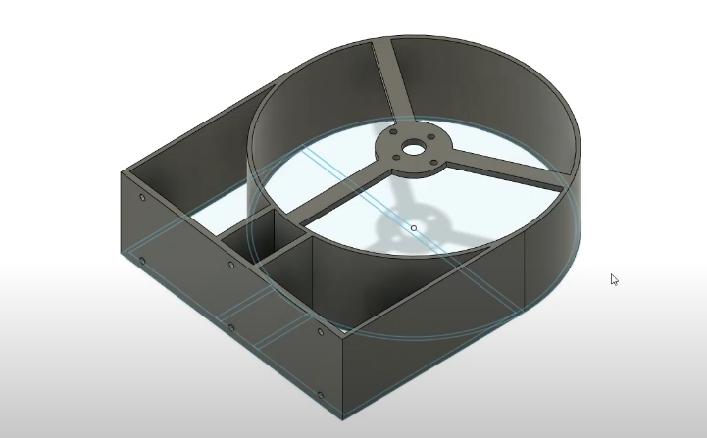

1. **Assembly and Connection:-**